2nd Announcement


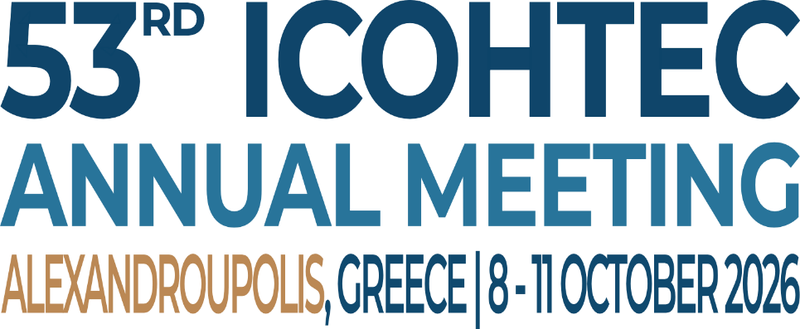
Engaging the History of Technology

 |  | 

https://icohtec2026.hs.duth.gr

Annual Meeting of the International Committee for the History of Technology (ICOHTEC)

8-11 October 2026, Alexandroupolis (Greece)

Engaging the History of Technology
Bridging Disciplines and Perspectives for Global Challenges

The 53rd annual meeting of the International Committee of the History of Technology (ICOHTEC) will be held at Democritus University of Thrace, in collaboration with the Laboratory of Technologies, Research & Applications in Education/ School of Humanities and the Ethnological Museum of Thrace in Alexandroupolis, Greece.

Climate change, environmental injustice, political polarisation, and artificial intelligence present challenges that are at once historical, cultural, ethical, environmental, and technological. In offering vital insights into how societies have imagined progress, structured power, exchanged knowledge, and engaged with environments, the history of technology can help foreground its importance in addressing contemporary challenges at a moment when humanities disciplines face shrinking resources and pressures to justify their value.

The theme of this conference, “Engaging the History of Technology”, invites critical reflections on how history of technology can engage with evolving methodologies, theories and pedagogies, and other branches of historical study to demonstrate that understanding technologies’ pasts are essential to navigating contemporary challenges. The conference, therefore, seeks contributions across spatial and epistemic boundaries: from the everyday and local to the geopolitical and planetary; from archival practice to classroom teaching and public engagement; and from discipline-specific research methods to interdisciplinary collaborations.
Contributors may engage with one or more of the following themes, or even suggest new ways of thinking about:
1. The History of Technology between the Local, the Regional, and the Global
- Circulation of technologies, expertise, and knowledge across borders
- Adaptation and appropriation of technologies in different cultural contexts
- Tensions between globalisation and localisation in technological change
- Regional networks and their role in shaping technological trajectories
- Colonial, postcolonial and decolonial dimensions of technology
- Networks of maintenance and repair

2. History of Technology, Historiography and Education
- Methodological innovations in researching the history of technology
- Interdisciplinary approaches and their challenges
- Teaching the history of technology in universities and schools
- Public engagement and the communication of technological history
- The relevance of technology history to contemporary policy debates
- Digital humanities and new forms of historical scholarship



3. Intersections between the History of Technology and Other Fields of Historical Study
- Technology and social history: class, labour, gender, and everyday life
- Technology and cultural history: representation, identity, and meaning
- Technology and environmental history: sustainability, resource use, and ecological change
- Technology and economic history: innovation, industrialisation, and development
- Technology and political history: governance, regulation, and power
- Technology and the history of medicine: cultural values, therapeutic practice, and material conceptions about the human body
- Technology and the History of Science: instruments, practices, knowledge
- Technology and the Philosophy of Science: epistemology, values, philosophical accounts of experimentation and modeling

4. Special Focus: Museums, Material and Intangible Cultural Heritage, and Public Engagement
Given our collaboration with the Ethnological Museum of Thrace, we particularly welcome proposals that engage with material and intangible culture, museum practices, and public history. We are interested in innovative session formats that:
- Explore tensions and synergies between academic and museum approaches to technological history
- Demonstrate object-based learning methodologies
- Address the challenges of communicating technological history to diverse publics
- Examine the role of museums in preserving and interpreting technological heritage
- Study visitor engagements with intangible heritage, particularly those of marginalised and silenced ethno-cultural communities
- Critically examine the funding relationships between private technological and industrial interests, and museum

Besides papers addressing the conference theme, we welcome contributions from all fields of the History of Technology.

We welcome proposals in the following formats:

- Paper presentations
Individual and author teams’ presentations. Please, submit an abstract of up to 350 words.

- Panel Sessions
Thematically coherent sessions of 3-4 papers. Panel organisers should submit a panel abstract (up to 400 words) describing the theme and its significance; after approval the conference committee and the panel organisers will issue a specific call for proposals (individual or author teams’ paper abstracts up to 350 words each).

- Roundtables
Discussion-based sessions with 4-6 participants addressing a specific question or debate. Organisers should submit a description of the topic and format (up to 350 words); names and brief bios of participants (up to 100 words each); key questions to be addressed.


- Graduate Student and Early Career Opportunities
ICOHTEC is committed to supporting emerging scholars. We particularly welcome submissions from graduate students and early career researchers. The conference will feature:
- Visual Lightning Talk Competitions for graduate students
- Mentorship opportunities pairing students with established scholars
- Book development workshops
- Career diversification panel


Submissions of abstracts through the conference website
Extended Deadline: | 28 February 2026
Conference Fees
 | Deadline:
Early Bird: 320 EUR | 30 April 2026
Late Registration: 400 EUR | 15 July 2026
Virtual Participation: 250 EUR  (limited spaces available for virtual participation) | 30 April 2026
Note: special discounts will apply to students and scholars from Low-Income countries

Official conference website: https://icohtec2026.hs.duth.gr
Email address: icohtec2026@gmail.com

8 – 11 October 2026
Alexandroupolis

https://icohtec2026.hs.duth.gr

